Taking care of myself for proper growth and development.

**Learning outcome:**

Caring for my eyes

**LESSON 1**

**Competence:**

Cares for and protects his / her eyes.

**Materials:** real body parts, visual aid, a drawn chart, water, towel, Vaseline

**Procedure:**

Discussing ways of caring and protecting his / her eyes.

* Washing
* Applying Vaseline
* Putting sun glasses

**Rhyme**

Wash wash wash your eyes don’t

Forget your teeth

Daily daily you look very smart

**Activity:**

Let a learner trace the eye



**LESSON 2**

**Competence:**

Cares for and protects his / her eyes

**Suggested materials:** real body parts, visual aid, a drawn chart, water , towel, soap, Vaseline

**Procedure:**

Discussing about the protection and care of his / her eyes.

**Rhyme:** Parts ---

Parts of my body

Eye is a part of ---

Leg is a part of ---

**Activity:**

Let the learner shade the eye.

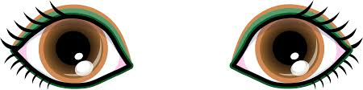

**LESSON 3**

**Competence:**

Cares for and protects his / her eyes

**Suggested materials:** real body parts, visual a drawn chart, water, towel, Vaseline

**Procedure:**

* Discussing ways of caring and protecting his / her eyes
* Washing eyes
* Applying Vaseline
* Putting on sun glasses

**Rhyme:**

Wash wash wash your eyes don’t forget

Your teeth daily daily you look very smart

**Activity:**

Let the learner copy and draw the eye.

|  |  |
| --- | --- |
| https://encrypted-tbn0.gstatic.com/images?q=tbn:ANd9GcRVq8f6qkecWiazzXMLcJvz6I5RpyoZLdqWA2SQDK_Lc6ZUNSKi |  |

**LESSON 4**

**Learning outcome:**

Caring for my eyes

**Competence:**

Cares for and protects his / her eyes

**Materials:** real body parts, visual , charts and real things that harm the eye.

**Procedure:**

Discuss things that harm eyes and identify things that harm eyes

**Rhyme**

My eyes are white and black

My lips are red they speak to you

Two ears one nose and this is me

**Activity:**

Let a learner identify and copy things that harm eyes.

|  |  |  |  |  |
| --- | --- | --- | --- | --- |
| stick-clipart-word-stickstick | kTKnKyrBcpin | a1cbbf93af84673bb07c943bf43ca0baneedle | BD04915_pencil | 4232235-xsstone |
|  |  |  |  |  |

**LESSON 5**

**Learning outcome:**

Caring for my eyes

**Competence:**

Cares for and protects his / her eyes

**Materials:** real body parts, visual aid, charts and real things

**Procedure:**

Discuss things that harm eyes and identify things that harm eyes.

**Rhyme:**

My eyes are white and black

My lips are red they speak to you

Two ears one nose and this is me

**Activity:**

Let a learner identify and colour things that harm eyes.

|  |  |  |  |  |
| --- | --- | --- | --- | --- |
| sand | BD07837_flower | dglxasset[1]  knife | nail | NA00809_sun |
|  |  |  |  |  |

**LESSON 6**

**Learning outcome:**

Caring for my eyes

**Competence:**

Cares for and protects his / her eyes

**Materials**: visual, charts, real objects that harm eyes

**Procedure:**

Discussing, matching things that harm eyes and identifying tings that harm eyes.

**Rhyme:**

Fire x 3 is for cooking food etc

**Activity:**

Let a learner match and identify things that harm eyes.

**Match**

Description: MC900112302[1]

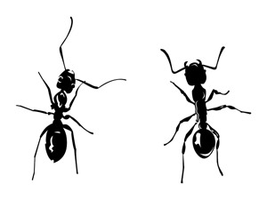

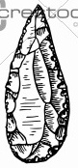

dglxasset[1]

**LESSON 7**

**Learning outcome:**

Caring for my eyes

**Competence:**

Cares for and protects his / her eyes

**Material:** real objects, visual, chart

**Procedure:**

Discussing things that harm eyes and fill in the missing letters

**Rhyme:**

Good morning Mr. Sun

How are you today

The day has began

Good morning Mr. Sun

**Activity:**

Let a learner fill in the missing sounds.

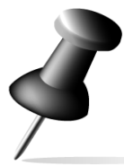pin p\_\_n NA00809_ sun s\_\_\_n 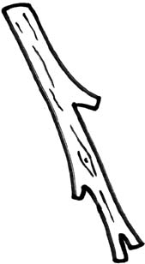 stick st \_\_ck pen p\_\_n

nail n \_\_il

**LESSON 8**

**Learning outcome:**

Caring for my eyes

**Competence:**

Cares for and protects his / her eyes

**Material:** real objects, visual, charts

**Procedure:**

Discussing and circling the right words for the things that can harm the eye

insect cat

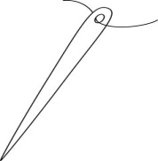 nail needle

 stick stone

Description: MC900112302[1] five fire

**LESSON 1**

**Learning outcome (II)**

**Competence:**

Protects and cares for his / her ears.

**Suggested materials:** visual, chart, real objects like soap, towel, water

**Procedure:**

Discussing way and how to protect his / her ears.

**Song**

Head shoulders knees and toes

Knees and toes eyes ears nose and mouth

**Activity**

Let a leaner copy and learn

|  |  |
| --- | --- |
| ear |  |

**LESSON 2**

**Learning outcome:**

Caring for my body

**Competence:**

Protects and cares for his / her body

**Materials:** visual aid. Real body parts, water, soap, basin, toothbrush, toothpaste, sponge, sandals, towel, brush, comb, nail cutter

**Procedure:**

Discussing ways of protecting our body

* Bathing
* Brushing
* Combing hair
* Cutting hair
* Cutting finger nails
* Applying Vaseline

Song:

Head shoulders knees and toes

Knees and toes eyes ears nose and mouth

**Activity:**

Let a learner match the same body parts

 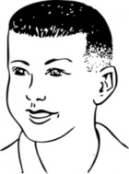

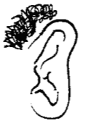 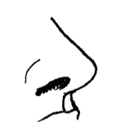

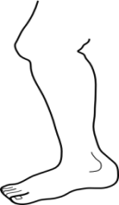 

 

 

**LESSON 3**

**Learning outcome:**

Identifying and naming different body parts and their uses.

**Suggested materials:** real body parts, visual. Charts

**Procedure:**

Discuss with the learners the ways and how to protect our body parts.

**Rhyme:**

Head shoulders knees and toes x 3

Knees and toes eyes ears nose and mouth

Pa la la

**Activity:**

Let the learners match pictures to their words.

 head

 ear

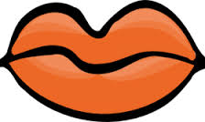 leg

 eye

 mouth

 nose

**Activity 2**

Let the learners copy and write the body parts

|  |  |  |  |
| --- | --- | --- | --- |
| https://encrypted-tbn0.gstatic.com/images?q=tbn:ANd9GcRVq8f6qkecWiazzXMLcJvz6I5RpyoZLdqWA2SQDK_Lc6ZUNSKieye | ear | nose | 13455797441999041598Leg%20Drawing leg |
|  |  |  |  |

**LESSON 4**

Identifying and naming different body parts and their uses.

**Competence:**

Naming his / her body parts

**Materials:** visual aid, real people, charts

**Procedure:**

Discuss with the learners the different parts of the body while showing them for example head, eyes, ears, nose, tongue etc

**Rhyme**

Head shoulders knees and toes x 3

Knees and toes eyes ears nose and mouth

Pa la la la la la x 2

**Activity:**

Let the learner match the same body parts.

 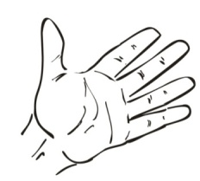

 

 

 

 

**LESSON 5**

Identifying and naming different body parts and their use.

**Competence:**

Naming his / her body parts

**Procedure:**

Discuss with the learners the different parts of the body and their uses e.g

* eyes for seeing ,
* nose for smelling
* ears for hearing
* tongue for testing etc

**LESSON 6**

**Learning outcome:**

Caring for my ears

**Competence:**

Cares for and protects his / her eyes

**Suggested materials:** real objects that can harm the ears, chart, visual aid

**Procedure:**

Discussing ways of caring and protecting plus identifying things that harm ears

**Rhyme**

Fire x 3 fire is for cooking food

Fire is for giving us light etc

**Activity:**

Let a learner copy and identify things that can harm the ears.

|  |  |  |  |
| --- | --- | --- | --- |
| Image result for beans clipart black and white  bean | bead | Sand | MP900401879[1]throne |
|  |  |  |  |

**LESSON 7**

**Learning outcome:**

Caring for my ears

**Competence:**

Cares and protects his / her ears

**Suggested materials:** real objects that can harm the ears, chart, visual

**Procedure:**

Discussing ways of caring and protecting his / her ears and naming things that can harm the ears.

|  |  |  |  |  |
| --- | --- | --- | --- | --- |
| kTKnKyrBc\_\_\_ | NA00809_ \_\_\_\_ | natural-ways-to-get-rid-of-ants\_\_\_ |  | Image result for beans clipart black and white |

Beans, sand, pin, thorn, sun, stick, insect, beads

**LESSON 8**

**Learning outcome:**

Caring for my ears

**Competence:**

Cars for and protects his / her ears.

**Suggested materials:** real objects, visual, chart

**Procedure:**

Discussing things that harm ears and read and draw things that can harm the ear.

**Questions:**

What do we use to hear?

Show me your ears

**Activity:**

Let a learner read and draw things that harm ears.

Bean\_\_\_ Pin\_\_\_\_\_\_\_ Axe\_\_\_\_\_ Pen\_\_\_\_\_ Panga\_\_\_\_\_ Nail \_\_\_\_\_

**LESSON 9**

**Learning outcome:**

Caring for my ears

**Competence:**

Cares for and protects his / her ears

**Suggested material:** real objects, visual, charts

**Procedure:**

Discussing things that harm ears and match things that can harm the ears to their names



Nail

Pencil

Fire

Beans

Pin

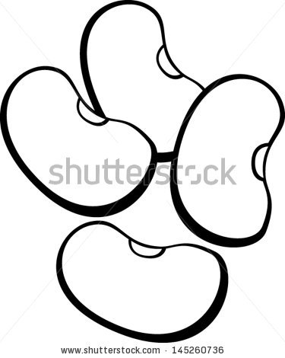

Description: MC900112302[1]

BD04915_



**LO VII**

**Lesson**

**Learning outcome:**

I identify and naming different body parts and their uses

**Competence:**

Names his / her body parts

**Suggested materials:** real body parts, visual, chart

**Procedure:**

Discuss with the learner the ways of caring for the body.

**Rhyme:**

Wash x 3 your face don’t forget your

Teeth daily x 3 you look very smart

**Activity:**

Let a learner learn ways of cleaning the body

MC900310258[1] 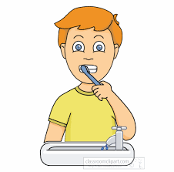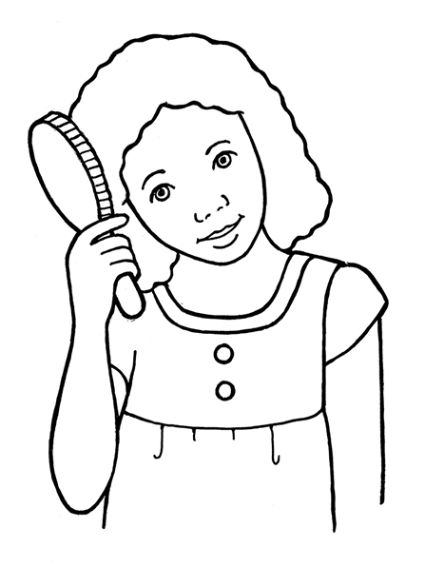 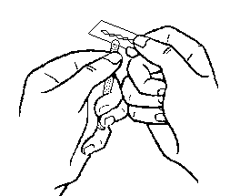

**LESSON**

**Learning outcome:**

Identify and naming different body parts and their uses.

**Competence:**

Name his / her body parts.

**Materials:** real body parts, visual, chart

**Procedure:**

Discuss with the learners things used to clean the body.

**Questions:**

What do we use to bathe?

What do we use to brush our teeth?

**Activity:**

Let a learner copy and draw things used to clean the body.

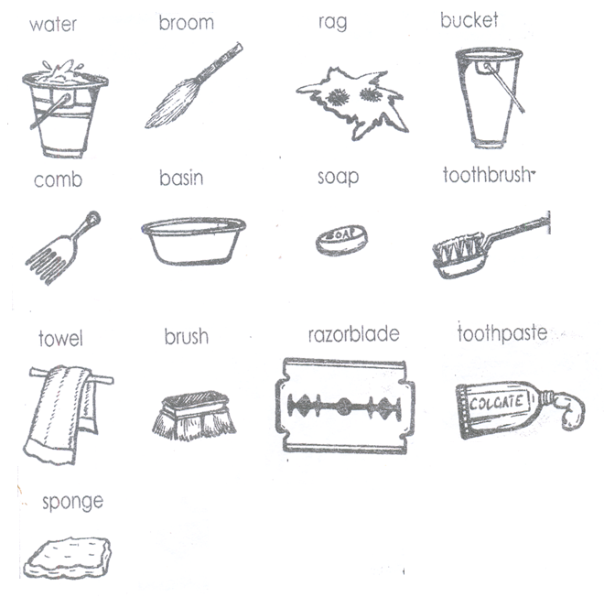

**Lesson learning outcome:**

**Competence:**

**Materials**: real objects,, towel, comb brush, sponge etc

**Procedure:**

Discussing ways of caring for the body and drawing the things used to clean the body

**Rhyme:**

Parts of my body head, hear etc

**Activity:**

Let a learner draw and write things used to clean the body.

Comb brush water soap towel

**Lesson**

**Lesson learning outcome:**

**Competence:**

**Materials:** real objects,, towel, comb brush, sponge etc

**Procedure:**

Discussing ways of caring for the body and matching the things used to cean the body to their names

Match

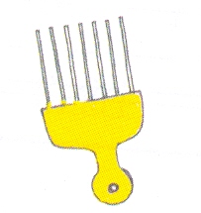 soap

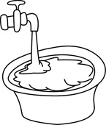 brush

Description: C:\Documents and Settings\esther\Local Settings\Temporary Internet Files\Content.IE5\CHC84USA\MC900371132[1].wmf tap

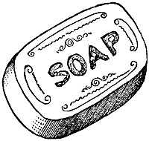 comb

**Lesson**

**Lesson learning outcome:**

**Competence:**

**Materials:** real objects, water, basin, soap, towel

**Procedure:**

Discussing ways of caring for the body and drawing yourself bathing.

**Activity:**

Let a learner draw and shade

Draw yourself bathing

**Lesson**

**Materials:** visual aid, real people, charts

**Rhyme:**

Head shoulders

Knees and toes x 3

Eyes ears nose and mouth

Palalala lalala x2

**Activity:**

Let the learners match body parts and their uses.

 touching

 hearing

 seeing

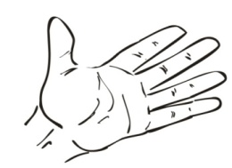 smelling

**Lesson**

Using gross and fine motor (large and small)muscles

**Competence:**

Uses his / her body parts to perform activities confidently.

**Materials:** free choice and outdoor work

**LOX**

**Lesson**

Expressing creativity free and independently

**Competence:**

Uses his / her body parts to express original ideas.

**Materials:** free choice and outdoor work

**Lesson 9**

**Learning outcome:**

Keeping healthy and practicing good health habits (LOXI)

**Competence:**

Appreciates good feeding

**Materials:** charts, flash cards, visual aid real food.

What is food?

Food is something good to eat or drink.

**Procedure:**

Discussing food we eat e.g cassava , rice, beans, posho, banana etc

**Rhyme:**

Fish fish fish

What a nice food when I eat fish

I grow fast and I get energy

**Activity:**

Let a learner identify types of food.

|  |  |  |
| --- | --- | --- |
| Bananas clipart  bananas | can-stock-photo_csp12567323yams | Image result for rice images  rice |
| Image result for beans clipart black and whitebeans | can-stock-photo_csp9456642cassava | Image result for fish images clip art  Fish |

**LESSON 10**

**Learning outcome:**

Keeping healthy and practicing good health habits

**Competence:**

Appreciates good feeding

**Materials:** Charts, flash cards, visual aid, real food,

What is food?

Food is something good to eat or drink.

**Procedure:**

Discussing food we eat and match

**Rhyme:**

Fish fish fish

What a nice food when I eat fish

I grow fast and I get energy

**Activity:**

Let a learner match the same types of food.

 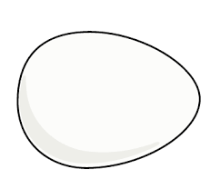

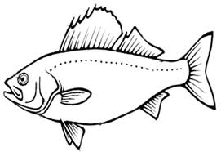 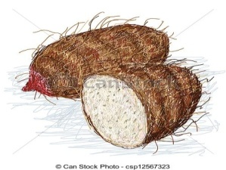

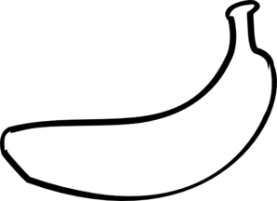 

 

 

**LESSON 13**

**Learning outcome:**

Keeping healthy and practicing good health habits.

**Competence:**

Appreciates good feeding.

**Materials:** charts, flash cards, visual aid, real food,

What is food? Food is something good to eat or drink.

**Procedure:**

Discuss with the learners the food we eat.

**Rhyme**

Fish fish fish

What a nice food when I eat fish

I grow fast and I get energy

**Activity:**

Let a learner copy and draw

|  |  |  |  |
| --- | --- | --- | --- |
| bean | ANd9GcQhJaEjaTkB3ntjzdVWG5atOY0WYxyygHbvfbVIWBbVpUSVMEiDegg | Image result for rice images rice | Sweet potato |
|  |  |  |  |

**LESSON 14**

Keeping and practicing good health habits

**Competence:**

I can identify food that is good for my healthy.

**Materials:** visual , real sources of food

**Procedure:**

Discuss with the learners about sources of food and identify them e.g market, shops, garden

**Song:**

I went to the market

I went to the butcher

**Activity:**

Let a learner identify and shade sources of food.

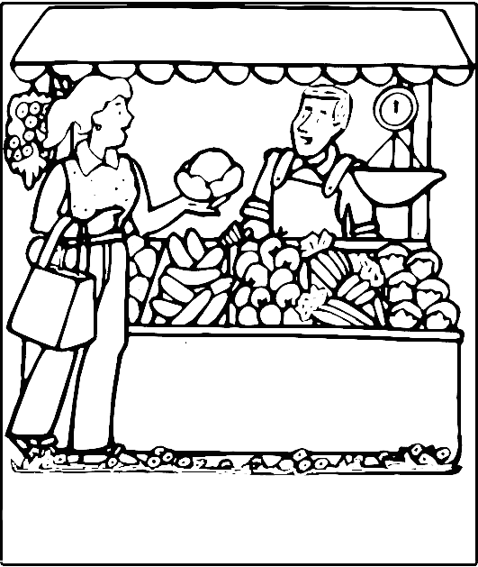 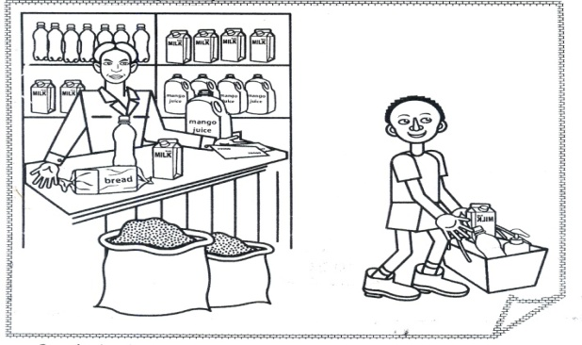 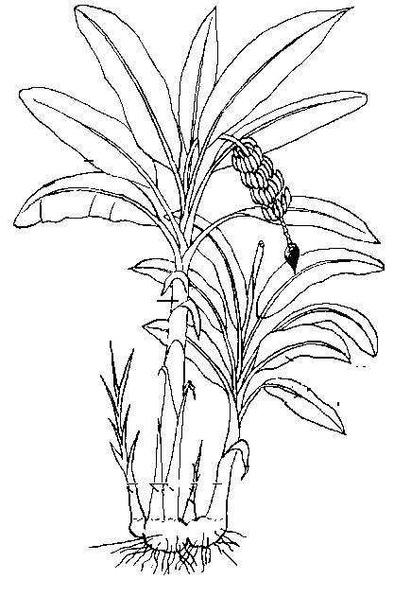

Market shop garden

**LESSON 15**

**Learning outcome:**

Keeping healthy and practicing good health habits

**Competence:**

I can identify food that is good for my health.

**Materials:** visual aid, real places, charts

**Procedure:**

Discuss sources of food e.g garden, market, shop and match

**Rhyme:**

I went in garden with my hoe

With my hoe I dig with my hoe

I dig with my hoe

**Activity:**

Let a learner match the same sources of food.

 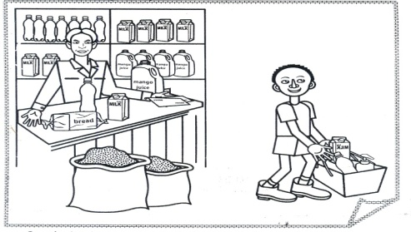

 

 

**LO XIII**

**Lesson 1**

**Learning outcome:**

Knowing relating with God and his creation

**Competence:**

Appreciate God’s love and cares for my creations.

**MORE PRACTICE WORK FOR TERM ONE**

**LEARNING AREA 3 (HEALTH HABITS)**

**Body parts**

**Read and match**

eye 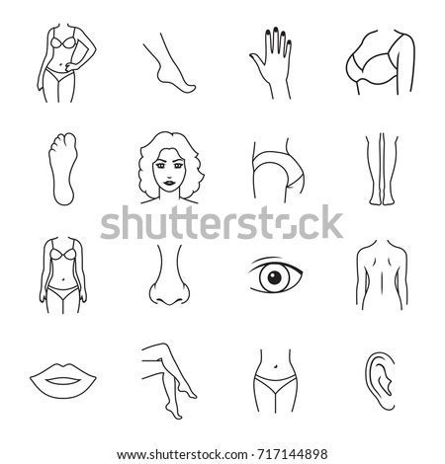

nose 

leg 

head 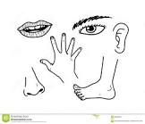

**Match to its word.**

  mouth

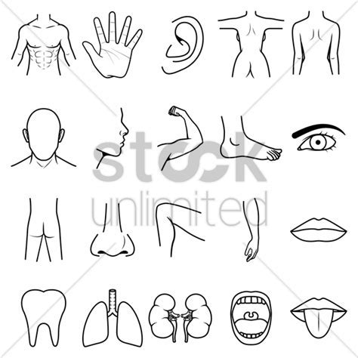 tongue

 ears

 arm

 nose

**Read and draw**

|  |  |  |
| --- | --- | --- |
| Ears | Head | Eyes |
| Mouth | Leg | Nose |

**Name the body parts**

  \_\_\_\_\_\_\_\_\_\_\_\_\_\_\_\_\_\_\_\_\_\_\_\_ \_\_\_\_\_\_\_\_\_\_

 \_\_\_\_\_\_\_\_\_\_\_ \_\_\_\_\_\_\_\_\_\_ \_\_\_\_\_\_\_\_\_\_\_

**Circle the correct word for the picture**

 eye eat

 noise nose

 ears elephant

 learn leg

 head herd

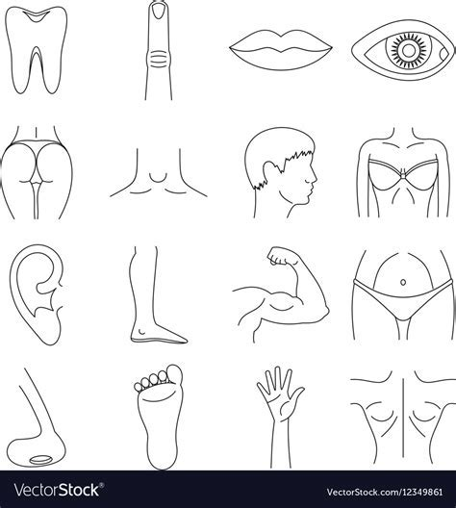 foot fingers

 mouth mat

**Fill in the missing letters**

n---se l---g ey------- m------uth t------ngue

t------eth h -----ad f-----ngers e-----r f-----ot

**THINGS WE USE TO CLEAN OUR BODY**

**Copy**

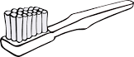toothbrush 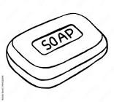soap 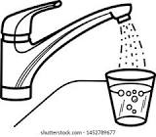water

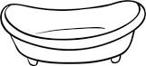basin 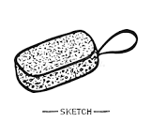sponge 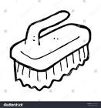brush

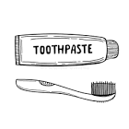toothpaste 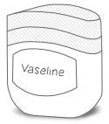vaseline 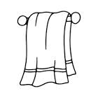towel

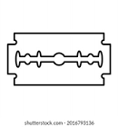razorblade

**Read and match**

brush 

sponge 

toothbrush 

water 

**Read and match**

soap 

razorblade 

towel 

toothpaste 

**Read and draw**

|  |  |  |
| --- | --- | --- |
| Brush | Razorblade | Towel |
| Toothbrush | Soap | Water |
| Sponge | Basin |

**Name these**

|  |  |  |  |
| --- | --- | --- | --- |
|  |  |  |  |
|  |  |  |  |

**Fill in the missing letters**

s-----ap w------ter sp-----nge b-----sin

t-----wel br-----sh t----othbrush toothp------ste

**THINGS WE WEAR**

**Copy**

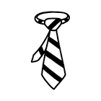tie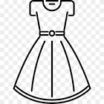dress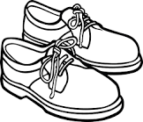shoes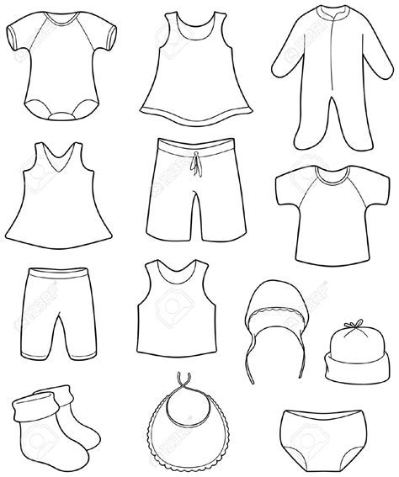 trouser

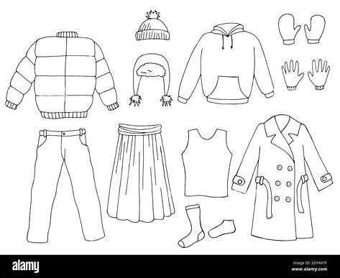jacketskirt  shirt

stockings 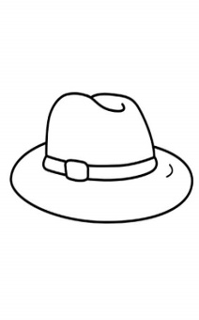 hat

**Read and match**

 Shoes

 Dress

 Shirt

 Socking

**Match**

 Short

 Hat

 Trouser

 Skirt

**Read and draw**

|  |  |  |  |
| --- | --- | --- | --- |
| short | skirt | hat | Shoes |
| trouser | jacket | tie | Dress |

**Name these**

\_\_\_\_\_\_\_\_\_\_\_\_ \_\_\_\_\_\_\_\_\_\_\_\_ \_\_\_\_\_\_\_\_\_\_

\_\_\_\_\_\_\_\_\_\_\_\_\_\_\_\_\_\_\_\_\_\_\_\_  \_\_\_\_\_\_\_\_

**Circle the correct word**

short shrto

ite tie

dress ssdre

sktri skirt

oesh shoes

sockings sckingso

**Fill in the missing letters**

j---cket tr----user dr-----ss t-----e

s----ckings sh----rt sk----rt

**DANGEROUS OBJECTS**

**copy and write**

stick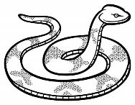snake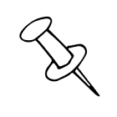 pin 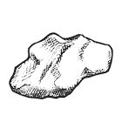stone 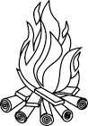 fire 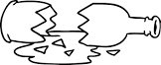broken bottle 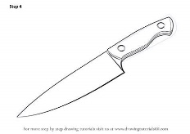knife 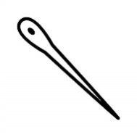needle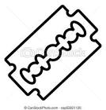razorblade

**Match and write**

 snake\_\_\_\_\_\_\_\_\_\_\_\_\_\_\_\_

 stone\_\_\_\_\_\_\_\_\_\_\_\_\_\_

 fire\_\_\_\_\_\_\_\_\_\_\_\_\_\_\_\_

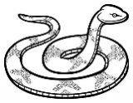 needle\_\_\_\_\_\_\_\_\_\_\_\_\_

**Match**

 knife

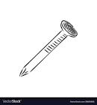 broken bottle

 stick

 nail

**Read and draw**

|  |  |  |
| --- | --- | --- |
| stone | broken bottle | Nail |
| knife | needle | Fire |
| stick | Snake |

**Name these**

\_\_\_\_\_\_\_\_\_\_\_\_\_\_\_\_\_\_\_\_\_\_\_ \_\_\_\_\_\_\_\_\_\_\_ \_\_\_\_\_\_\_\_\_\_  \_\_\_\_\_\_\_\_\_\_\_\_\_\_\_\_\_\_\_\_\_

\_\_\_\_\_\_\_\_\_\_\_\_\_ \_\_\_\_\_\_\_\_\_\_\_\_\_\_\_\_\_\_\_\_\_\_\_\_

**Fill in the missing letters**

Kn---fe st-----ne n-----edle fir--------

n-----il h------e sn --------ke p--------n

br------ken bottle st-----ck

**FRUITS**

**copy and draw**

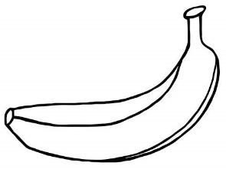yellow banana 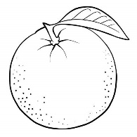orange

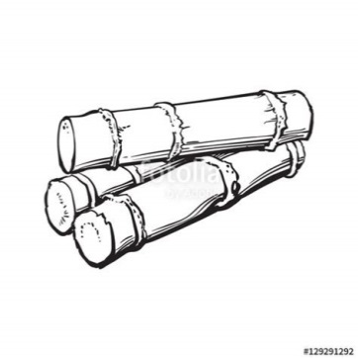sugarcane 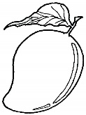mango 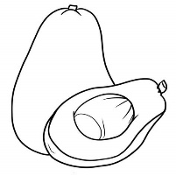avocado

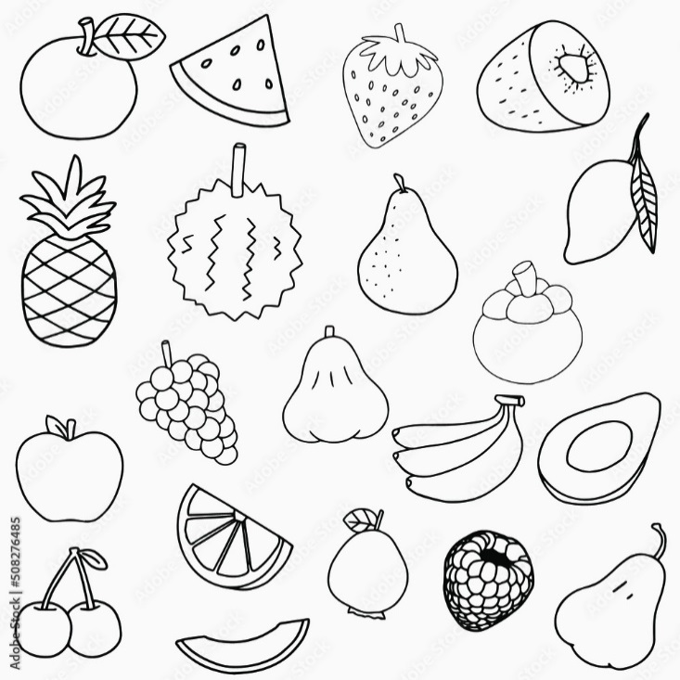pineapple 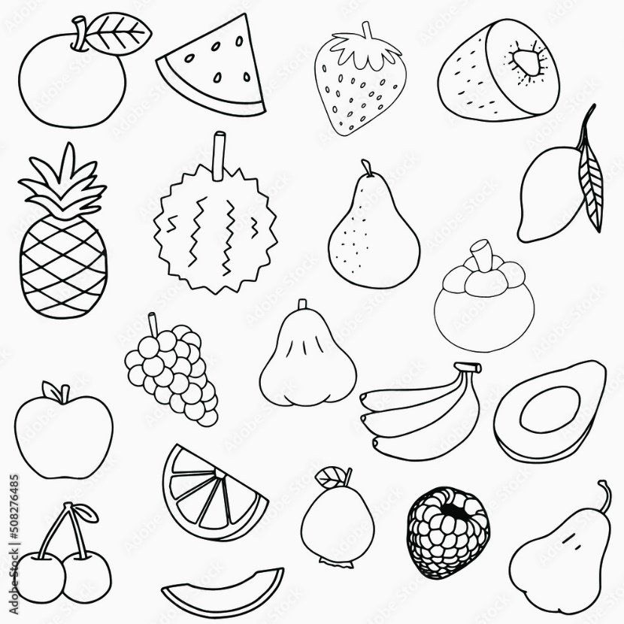apple 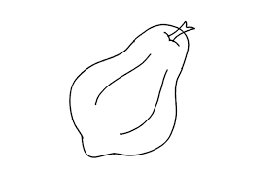pawpaw

**Read and match**

mango 

jackfruit 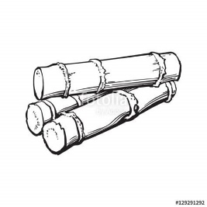

apple 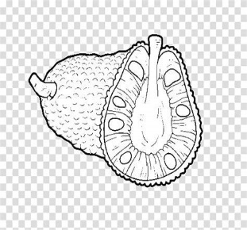

sugarcane 

**Match and write**

 tomato\_\_\_\_\_\_\_\_\_\_\_\_\_\_\_\_\_

 pineapple\_\_\_\_\_\_\_\_\_\_\_\_\_\_\_

 pawpaw\_\_\_\_\_\_\_\_\_\_\_\_\_\_\_\_\_

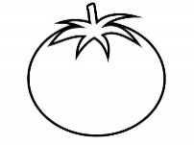 orange\_\_\_\_\_\_\_\_\_\_\_\_\_\_\_\_\_\_\_

**Name these**

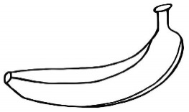\_\_\_\_\_\_\_\_\_\_\_\_\_\_ 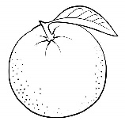\_\_\_\_\_\_\_\_\_\_\_\_  \_\_\_\_\_\_\_\_\_

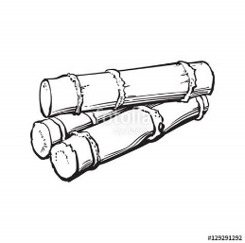\_\_\_\_\_\_\_\_\_\_\_\_\_\_\_ \_\_\_\_\_\_\_\_\_\_\_\_ \_\_\_\_\_\_\_\_\_\_\_\_

**Read and draw**

|  |  |  |
| --- | --- | --- |
| Pawpaw | Orange | Sugarcane |
| Tomato | Apple | Pineapple |
| Mango | Jackfruit |

**Fill in the missing letters**

s---garcane ------pple p----neapple

j-----ckfruit or-------nge p-----wpaw

w------termelon av-------cado y-----llow banana